**AES MINI PROJECT**

**Aim:** Using Arduino UNO, display temperature and humidity on LEC display which is being sensed by DHT11.

**Code:**

Libraries added: DHTLib, LiquidCrystal I2C

Project Link: https://wokwi.com/projects/328559462521504339

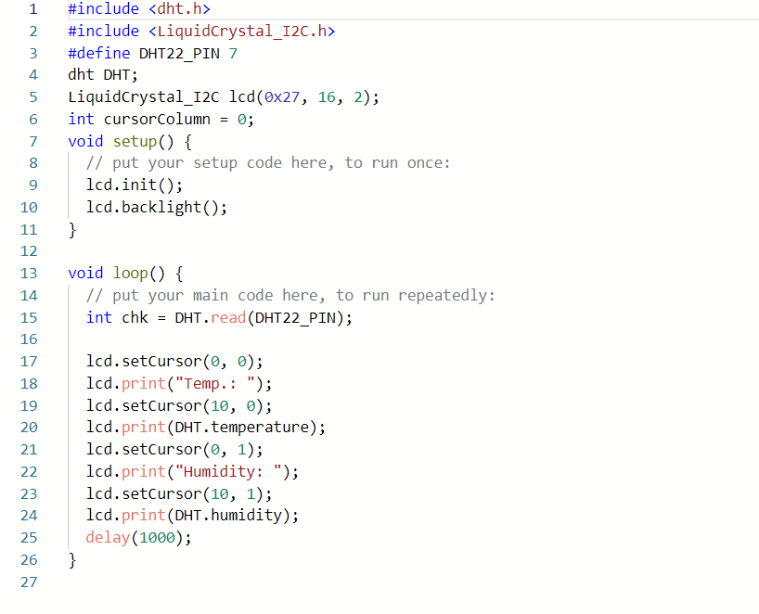

**OUTPUT:**

